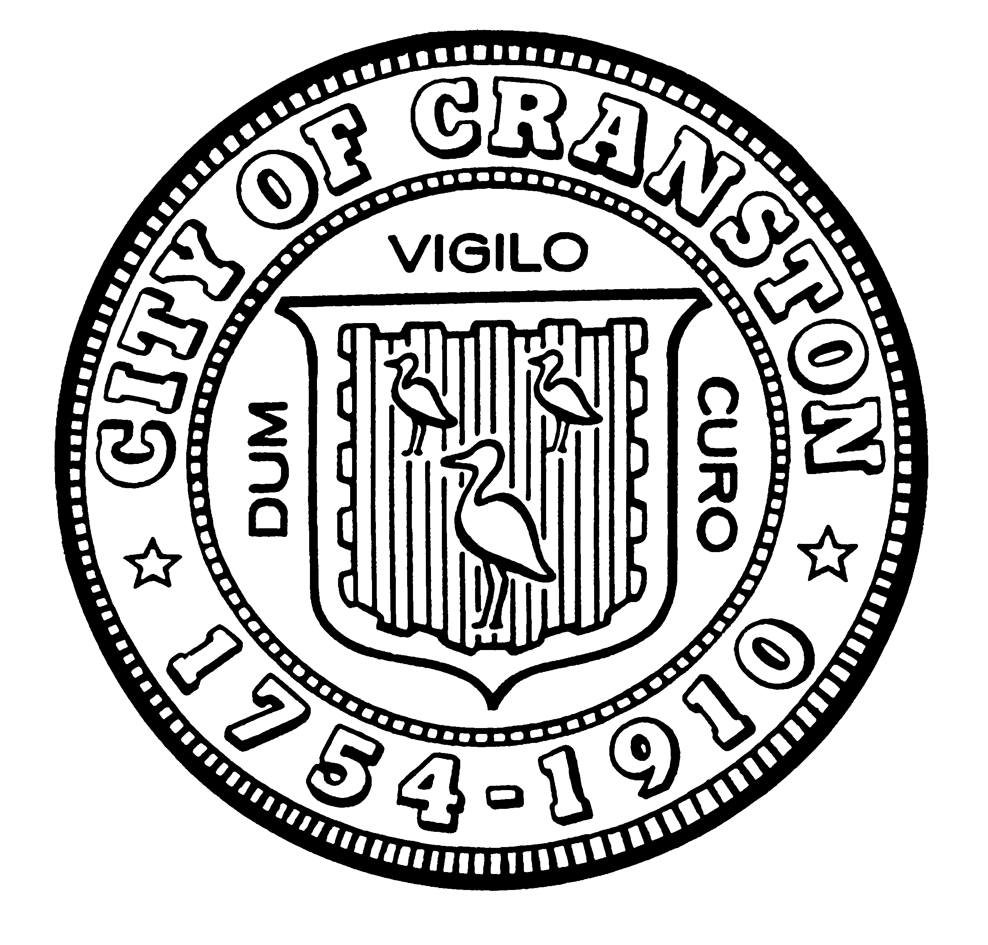

HOUSING COMMISSION

Annette Mann Bourne, Chair
Robert Santurri Jr, OneCranston Health Equity Zone, Vice Chair
Amy Rainone, Secretary
Ernest Tommasiello, Director, Department of Community Development
Jason Case
Frank DiZoglio III
Joanne McGunagle, CCAP
Jason M. Pezzullo, Planning Director
Derik Tutt

WEDNESDAY FEBRUARY 1, 2023 @ 5:30 P.M.
Cranston City Hall, 869 Park Avenue
3rd Floor Conference Room

MONTHLY MEETING AGENDA

- Approval of minutes of January 4, 2023 meeting (for vote)
- Share updated presentation for February 27 City Council meeting (for discussion)
- Discuss updating and communicating ARPA housing related spending priorities to the City Council (for discussion and possible vote)
- Discuss Land Use/ Zoning changes that could stimulate housing development in Cranston (for discussion)
- New business (for discussion)

“Individuals requesting interpreter services for the hearing-impaired must notify the Office of the City Clerk at 461-1000 Ext. 3197 seventy-two (72) hours in advance of the hearing date.”

